# (WIC Assignment) Individual Contribution to Project

### Section 1: Visualizations

#### Visualization 1: Major Components of the Project

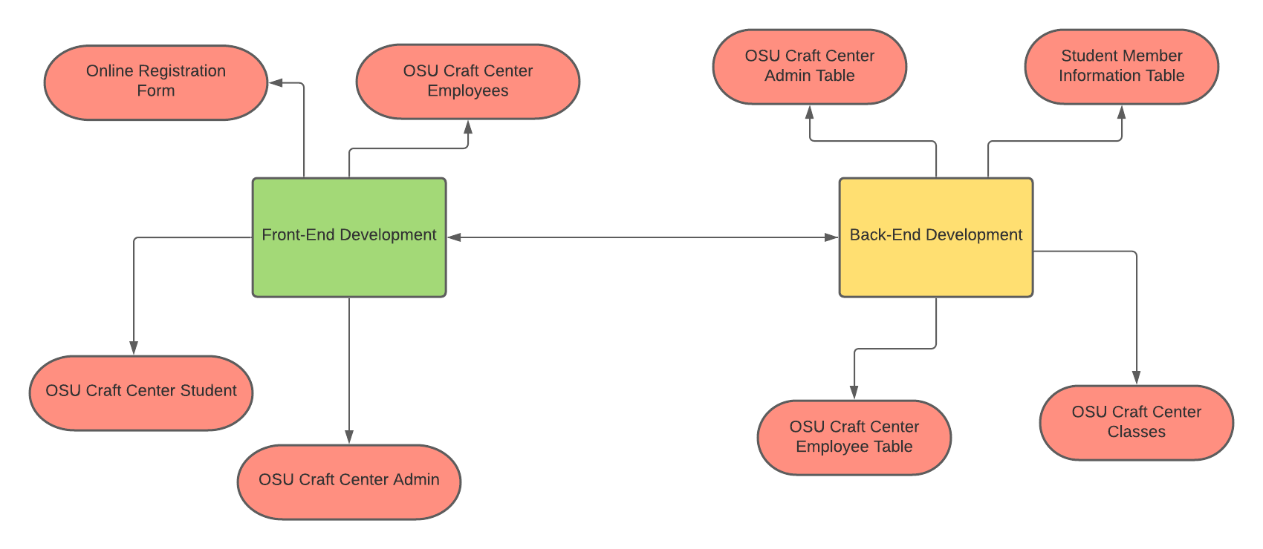

#### Visualization 2: Break Down to the Component which I’m responsible for in the Project

***OSU Craft Center Student***

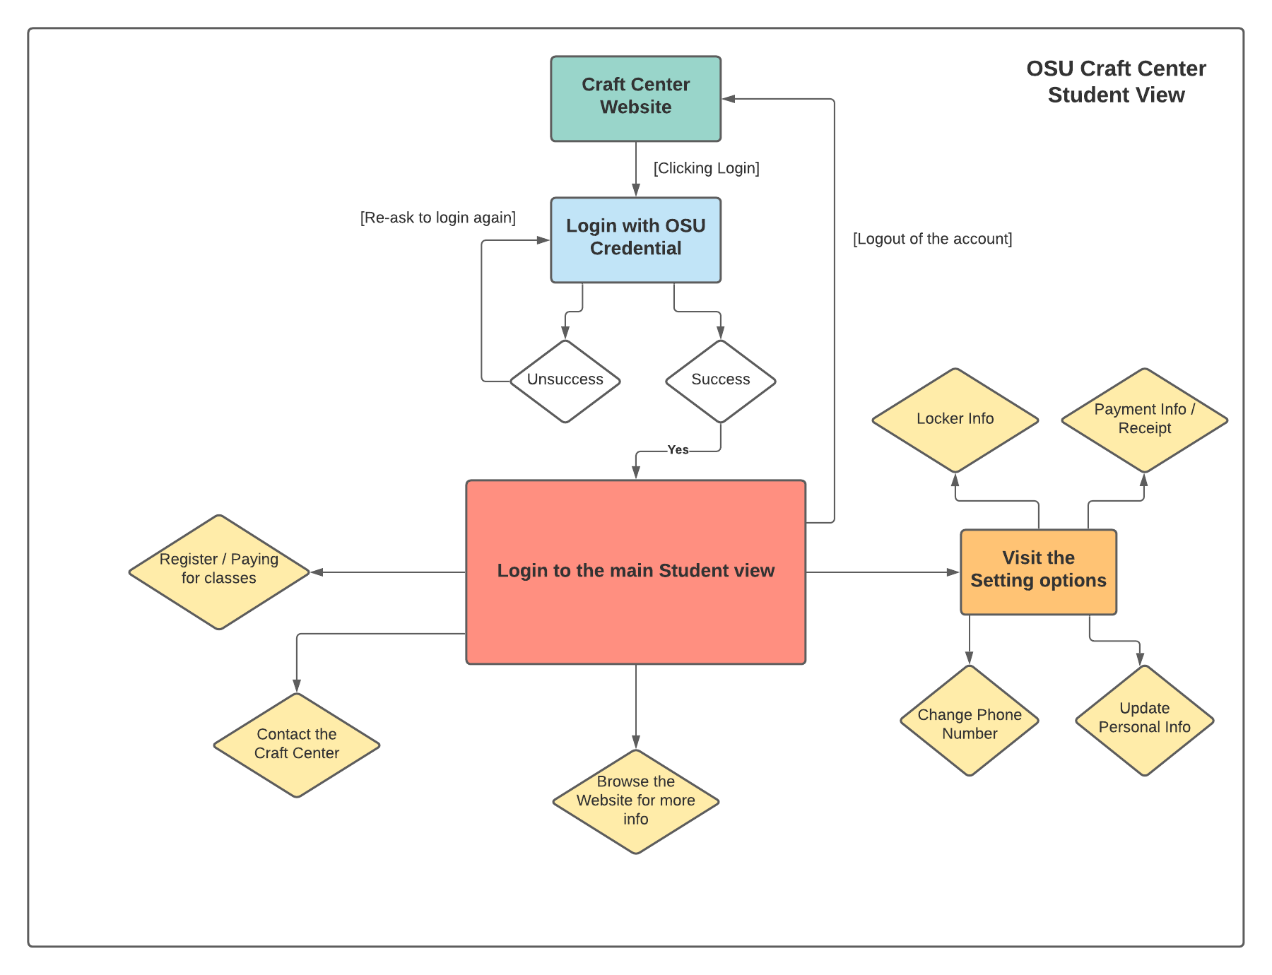

***Online Registration Form***

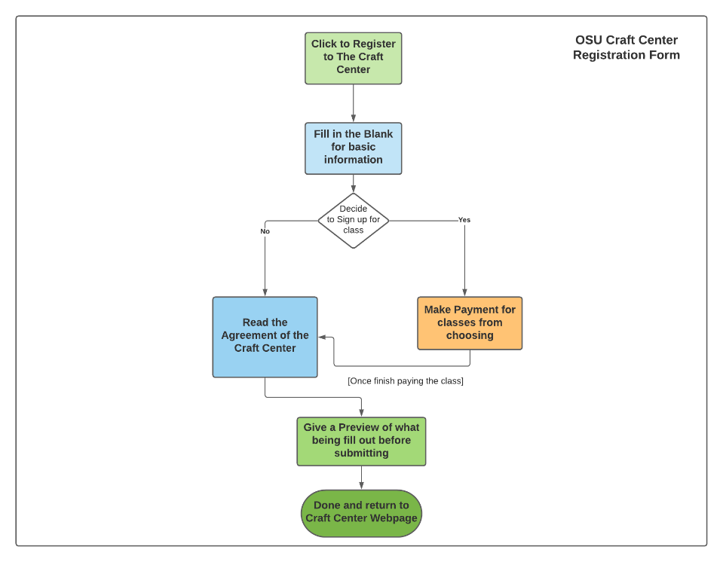

### Section 2: User Stories

User Story 1:

As an ***OSU student***, I need a way to register online to become as a member of the OSU Craft Center so that I can manage to do it via home or other locations without the need to physically be at the Craft Center to register.

User Story 2:

As an ***employee*** at the Craft Center, I need a database to look through all the members that has been registered to the Craft Center. That way I can pull up the information I need for that member faster than browsing it through an Excel sheet.

User Story 3:

As a ***project partner*** at the Craft Center, I need a well-documented and detail project layout so that later on down the road, if the project is not complete in time, I will have a good documentation to pass it down to the next group who’s going to tackle on it next.

User Story 4:

As a ***third-party member of the project (CASS)***, I need a well layout and easy-to-understand system of the online registration portal at the Craft Center so that I will have an easier time managing the system once the group publish the project online.

User Story 5:

As an ***admin*** at the Craft Center, I need a good level of access between public/student, employee, and admin when it comes to the database and other online access. So that I can see the correct content that I can see and have the correct control at what level I am in the workplace hierarchy.

### Section 3: Personal Iteration Plan and Estimations

My personal contribution towards the project will include the front-end design of the Craft Center project. Working with another member in the teams, we will design a way to make the interface layout that is easily usable for everyone. In the end, we will make the product very clear and easy to use while working at the front-end development side.

In the front-end development, I am responsible for the ***student view*** and the ***online registration form*** format when it comes to the experience of interacting with the Craft Center. In section No.1, you can view the flowchart layout of how each component are going to function base on their name component. With this in mind, the timeline that I have when tackling on this is to build a prototype layout using ***Figma*** during this time in Fall term. Then, after presenting it to the back-end team and the project partner, I will take collective feedback from both group and then implement the layout during the first month of Winter term. Through the end of the month, I will contact our other members in the team to present what I have and try to see if the front-end will work well with the progress work with the back-end team.

### Section 4: Solution Architecture

The design choice we made collectively as a group is to scrap the original team idea and moving forward with ***PHP MySQL***, ***JavaScript***, ***Node***, and any other tools we may mention it down the road. We made this decision due to the last group used ***C#*** to code their project based off of their work, it took them a while to learn the whole process to code the online portal for the Craft Center. We were thinking initially to follow this route, but time is constraint, so we decided as a group to move the project into an easier coding language to handle with in both our front and back-end portion.

Beside that, on the design choice for my end, I will follow the group choices collectively using Node to work for the front-end spectrum, but will use another tool to help out with designing and going along the way of the implementation. I will also be choosing ***Figma*** (as mention in Section No.3) as part of the tool that I think will be good for the design choice. This way, I can use this to build a prototype of how the interface will layout and how it will navigate through the student view and the online registration form. I will also bring this up to the team to see if they are good with this program to use for prototyping. On top of that, I will also choose to get reference of UI from the previous group as part of my choice for the project architecture to help with the project down the road.